**PROJECT TITLE : Smart Hotel Booking Management System Using**

**Phase 3: Data Modelling & Relationships**

1. **Standard & Custom Objects** 
   * **Standard Objects we can leverage:**
   * **User** → Roles like Admin, Front Desk, Manager
   * **Custom Objects:**

* **Guest (Guest__c)** → Stores guest details

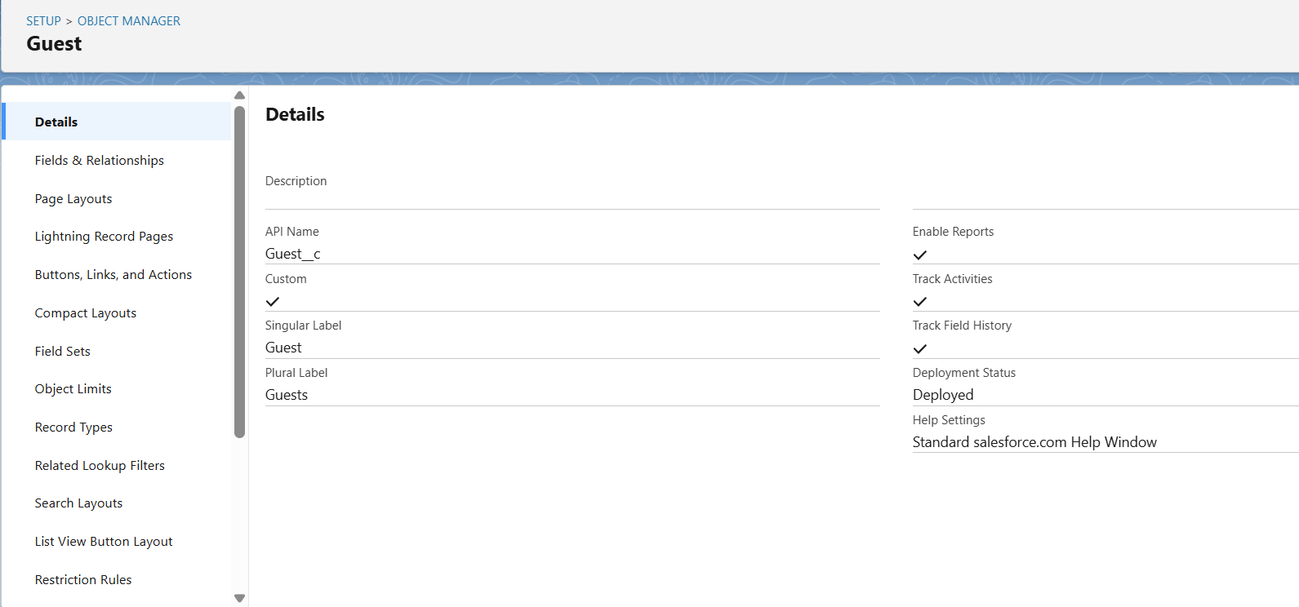

* **Booking (Booking__c)** → Tracks guest bookings
* 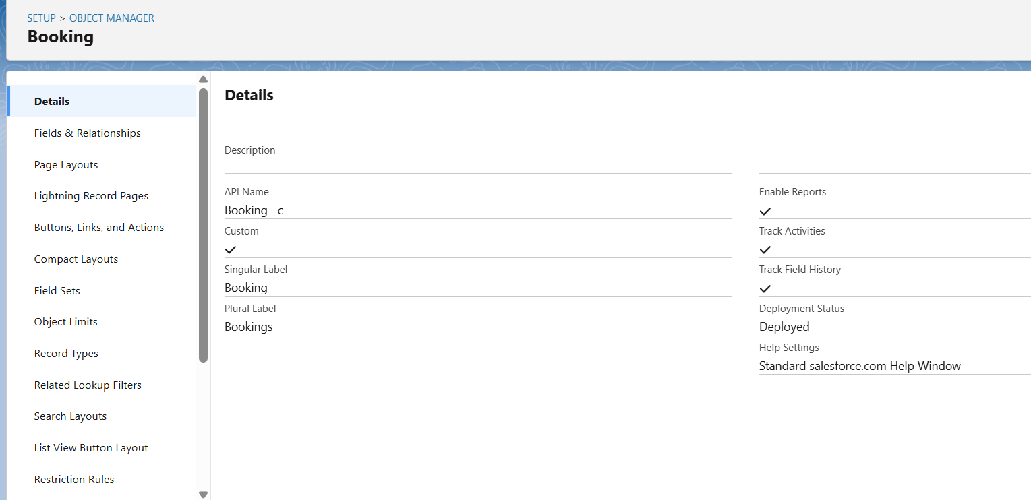

* **Room (Room__c)** → Stores hotel room information

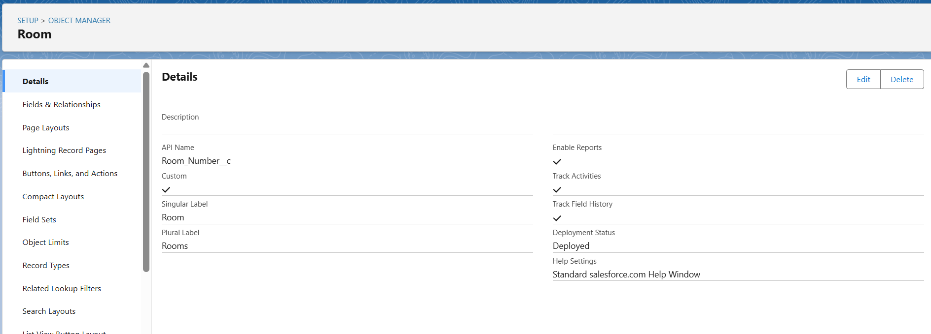

* **Payment (Payment __c)** → **Payment is used** to record and manage the financial transaction for booking a room, ensuring the hotel receives the correct amount, tracks what has been paid, what is due, and provides a record for accounting, refunds, or audits.

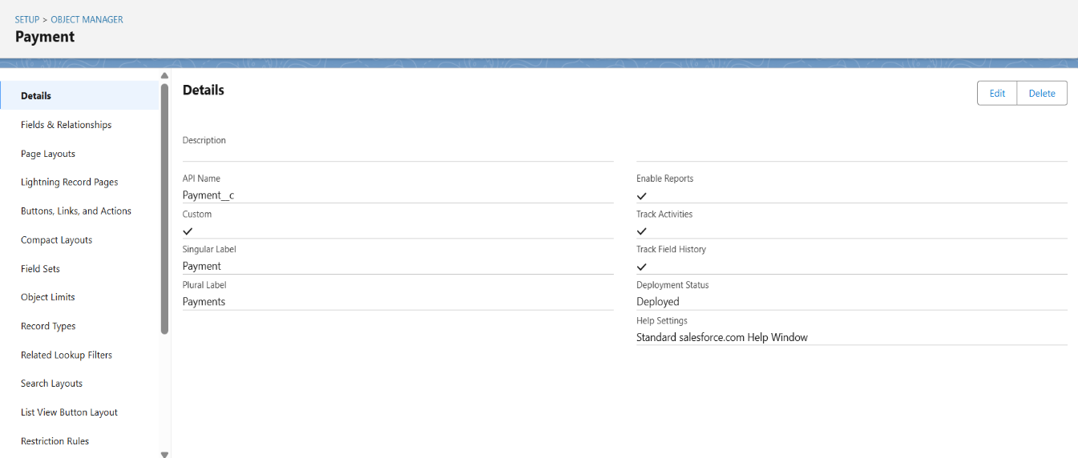

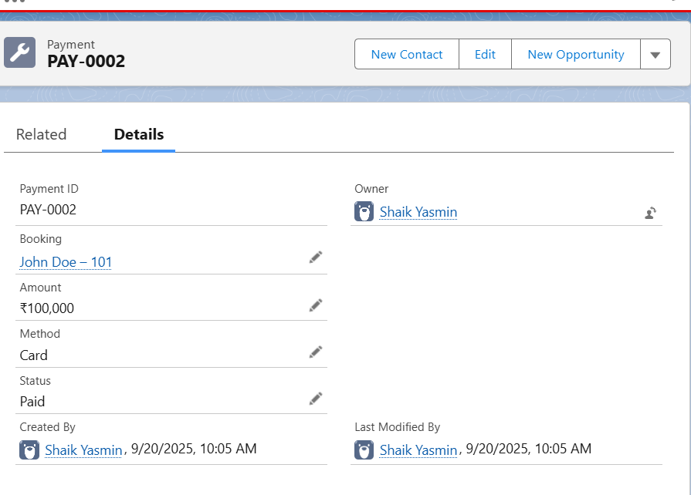

1. **Fields: Guest (Guest__c)**

| **Field** | **Data Type** | **Details** |
| --- | --- | --- |
| **Guest Name** | **Text** | **Record Name** |
| **Date of Birth** | **Date** |  |
| **Email** | **Email** |  |
| **Phone** | **Phone** |  |
| **Address** | **Text Area** |  |
| **Nationality** | **Picklist** | **Indian, American, European, Other** |
| **ID Proof** | **Picklist** | **Passport, Aadhaar, Driving License, Other** |
| **ID Proof Number** | **Text** |  |
| **Loyalty Status** | **Picklist** | **Regular, Silver, Gold, VIP** |
| **Number of Bookings** | **Number** | **Auto-calculated or manual** |
| **Owner** | **Lookup(User, Group)** | **Record owner** |
| **Created By** | **System** | **Auto** |
| **Last Modified By** | **System** | **Auto** |

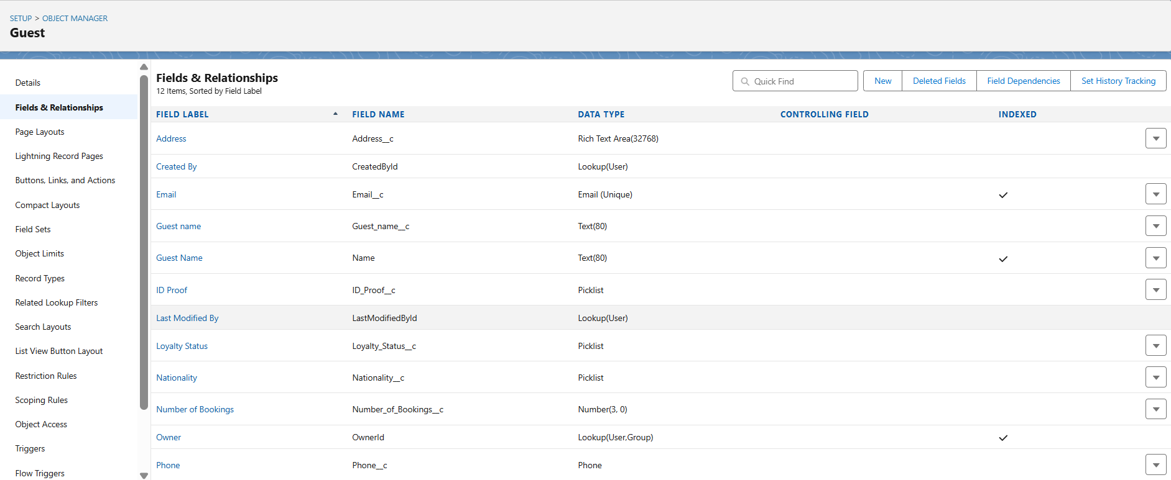

#### **Booking (**Booking__c**)**

| **Field** | **Data Type** | **Details** |
| --- | --- | --- |
| Booking Name | Text | Record Name |
| Guest | Lookup(Guest) | Links Booking to Guest |
| Room | Lookup(Room) | Links Booking to Room (Required) |
| Room Number | Text | Auto-filled from Room |
| Check-in Date | Date |  |
| Check-out Date | Date |  |
| Status | Picklist | Confirmed, Pending, Completed, Cancelled |
| Payment | Picklist | Paid, Unpaid, Partial |
| Payment Method | Picklist | Cash, Card, Online |
| Owner | Lookup(User, Group) | Record owner |
| Created By | System | Auto |
| Last Modified By | System | Auto |

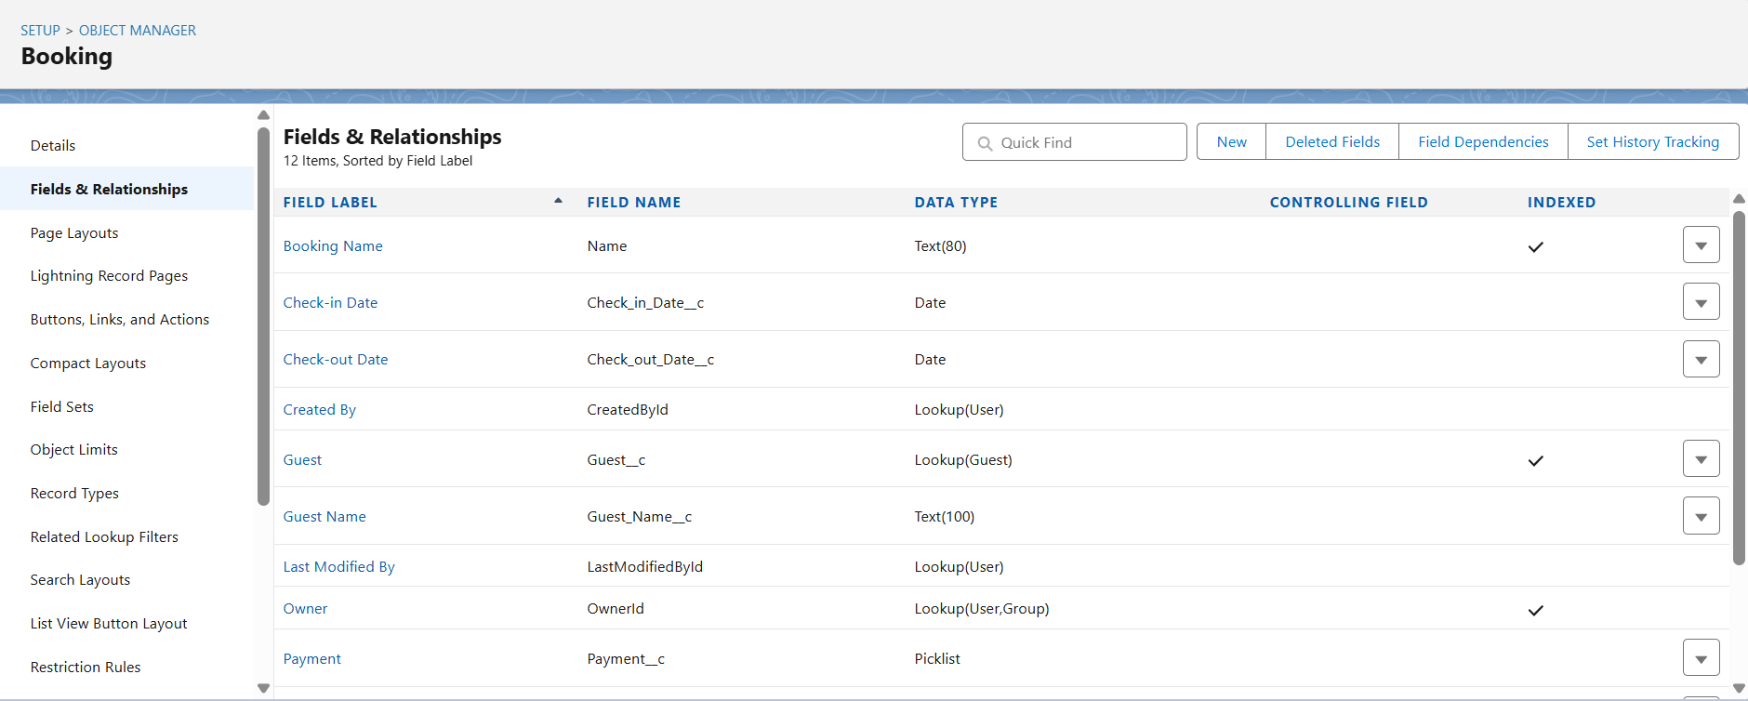

**Room (Room__c)**

| **Field** | **Data Type** | **Details** |
| --- | --- | --- |
| **Room Number** | **Text** | **Unique, required** |
| **Room Type** | **Picklist** | **Standard, Deluxe, Suite, VIP** |
| **Floor** | **Number** | **Optional** |
| **Price** | **Currency** | **Room rate** |
| **Status** | **Picklist** | **Available, Booked, Maintenance** |
| **Owner** | **Lookup(User, Group)** | **Record owner** |
| **Created By** | **System** | **Auto** |
| **Last Modified By** | **System** | **Auto** |

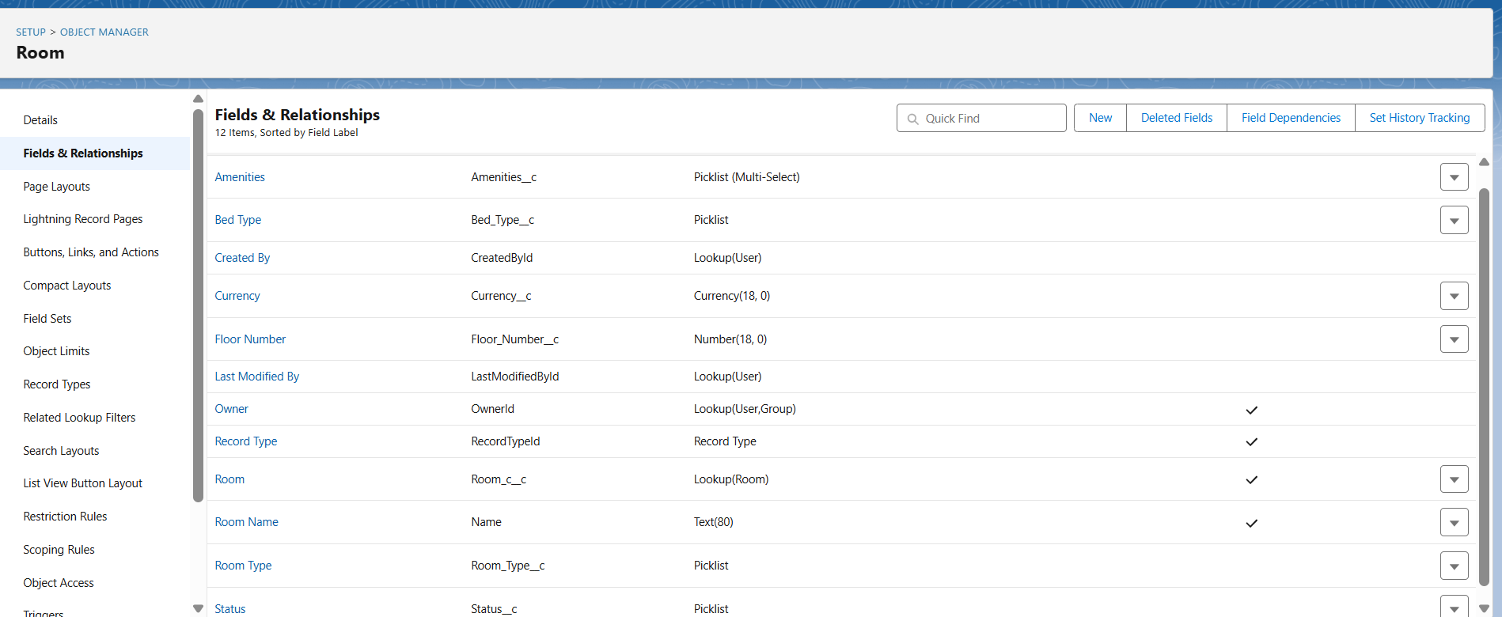

1. **Record Types:**

**Rooms — Record Types**

* + Record Types allow you to **differentiate Room layouts and fields** based on the type of room.

| * + **Record Type Label** | * + **Description** | * + **Active** | * + **Notes** |
| --- | --- | --- | --- |
| * + Standard Room | * + Regular single/double | * + True | * + Used for normal rooms |
| * + Standard Room1 | * + Luxury suite room | * + True | * + Used for luxury suites |
| * + Suite Room | * + (No description) | * + True | * + Likely for premium suites |

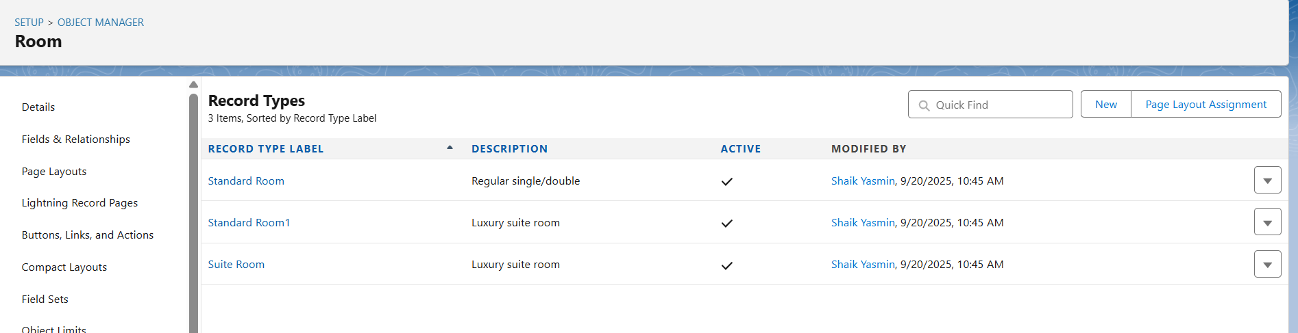

1. **Page Layouts:**

**Guest Layout**

* Personal Info: Guest Name, DOB, Nationality, Email, Phone, Address
* Loyalty Info: Loyalty Status, Number of Bookings
* ID Proof: ID Proof Type, ID Proof Number
* System Info: Created By, Last Modified By, Owner

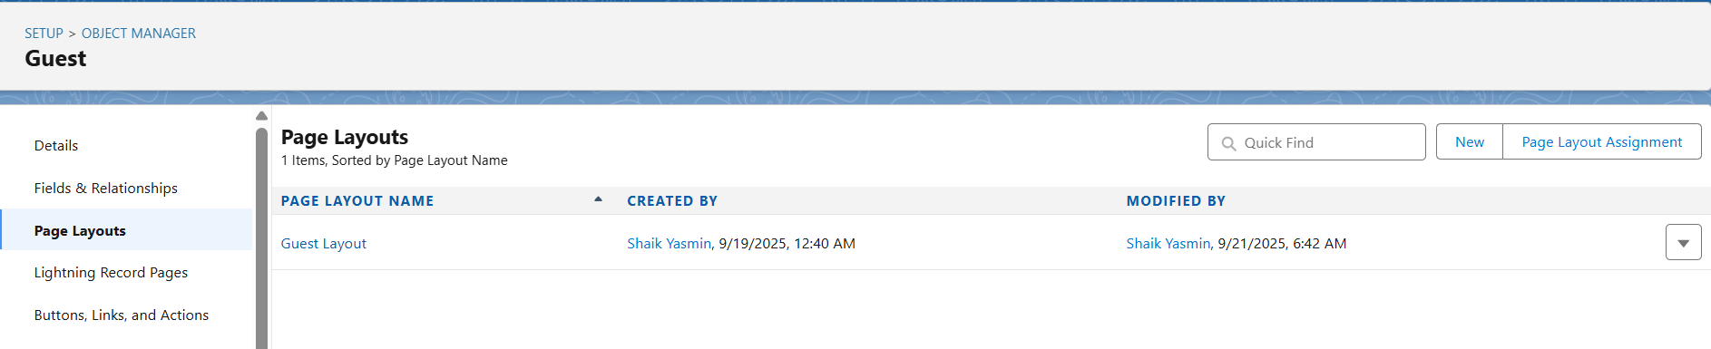

**Booking Layout**

* Information: Booking Name, Guest, Room, Room Number, Status, Payment, Payment Method, Check-in Date, Check-out Date
* System Info: Created By, Last Modified By, Owner

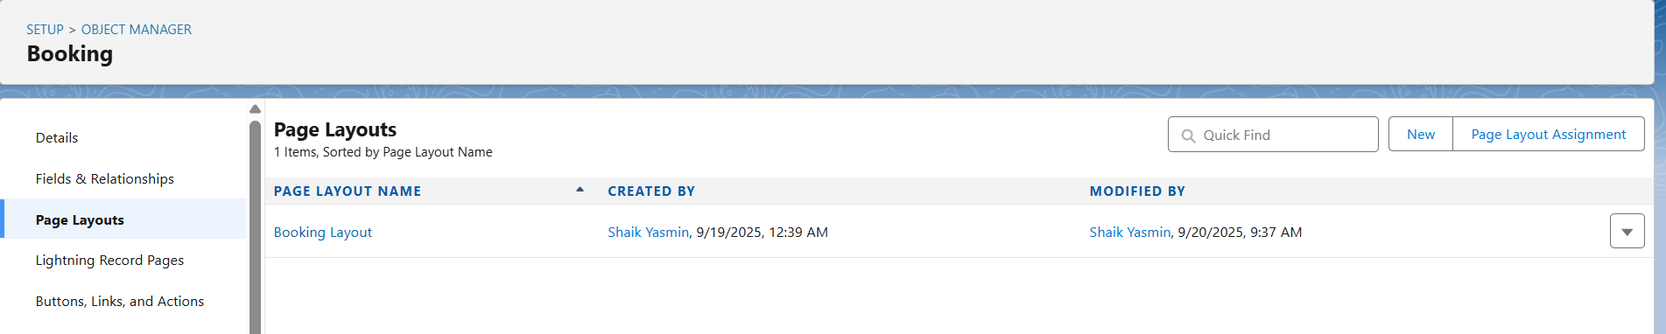

**Room Layout**

* Room Details: Room Number, Room Type, Floor, Price, Status
* 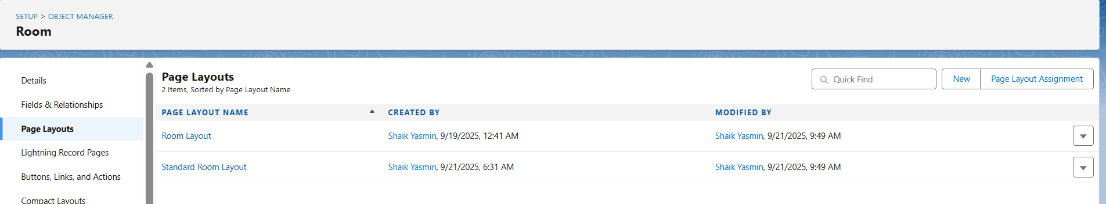System Info: Created By, Last Modified By, Owner

**5. Compact Layouts:**

This ensures that users see the most critical record information at a glance in the highlight panel.

**Guest Compact Layout:** Guest Name, Loyalty Status, Number of Bookings, Phone, Email 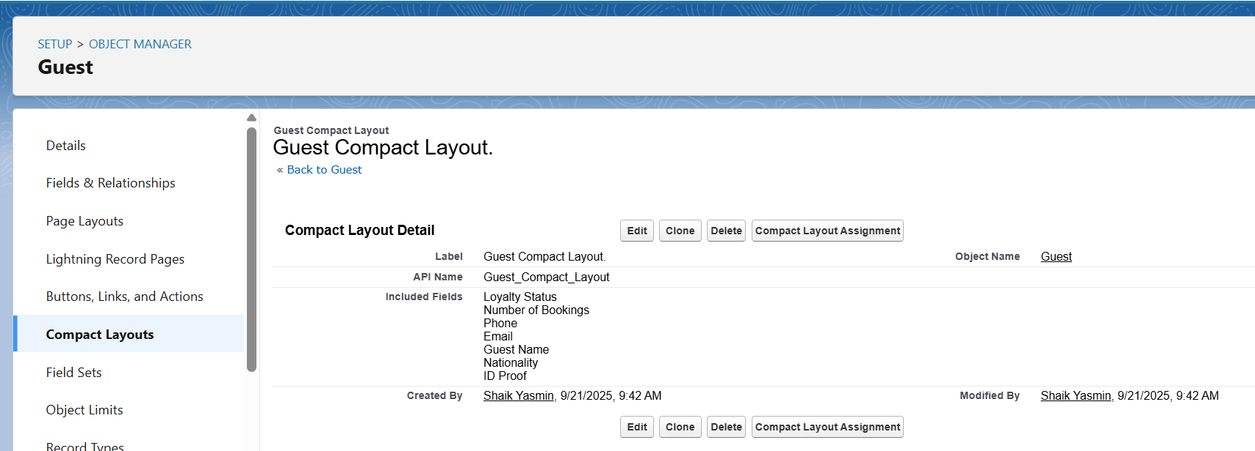

**Booking Compact Layout:** Booking Name, Guest, Room, Check-in, Check-out, Status 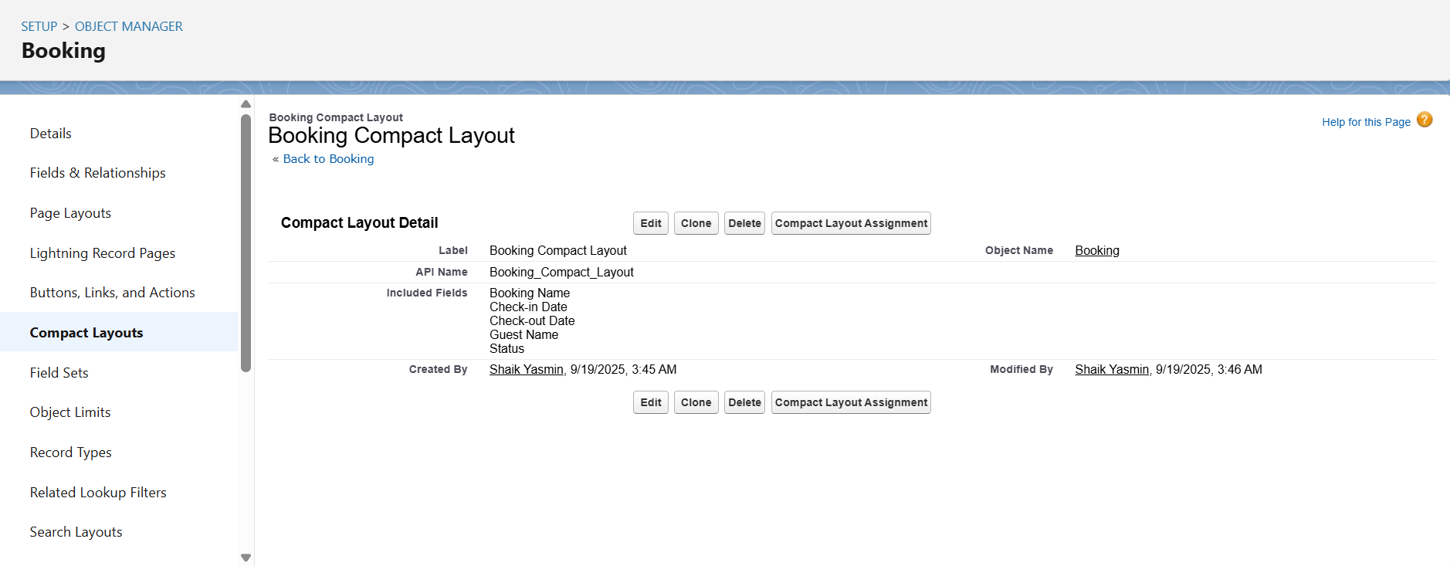

**Room Compact Layout:** Room Number, Room Type, Price, Status 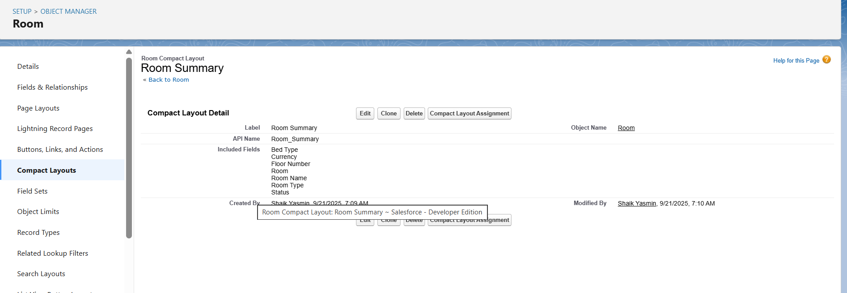

# 6)Schema Builder Schema View

• Guest → Booking → Room

• **Relationships**:

* Booking lookup to Guest
* Booking lookup to Room

• Bookings appear in Guest Related List and Room Related List

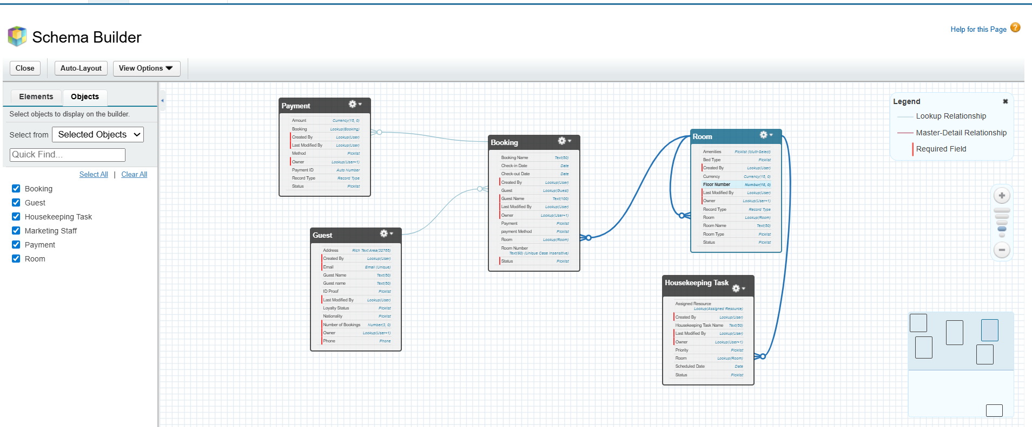

1. **Junction Objects:**

No junction objects created, junction objects could be added for advanced scenarios like if we want to track **multiple Customers linked to a single Claim** or if we want to link a **single Investigation to multiple Claim.**

1. **External Objects:**

No external Objects created, could be added for real-time fraud scoring by connecting Salesforce with external transaction data sources.